User case guest

Over View

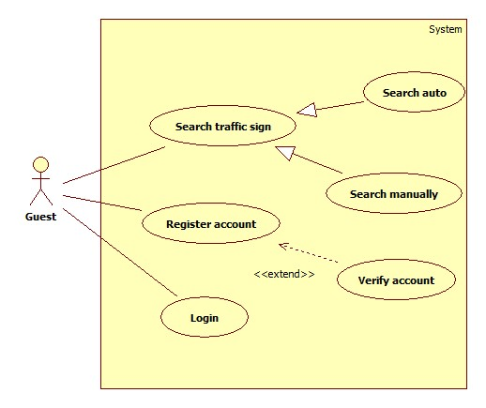

Login

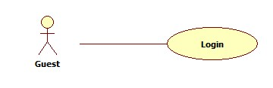

|  |  |  |  |
| --- | --- | --- | --- |
| **USE CASE – GU001** | | | |
| **Use Case No.** | GU001 | **Use Case Version** | 2.0 |
| **Use Case Name** | Login | | |
| **Author** | Tran Le Tuan | | |
| **Date** | 15/01/2014 | **Priority** | Normal |
| **Actor:** Guest.  **Summary:**  Guest use this case to login into system.  **Goal:**  Allow authentication and authorization of the system.  **Triggers:**   * Guest want to login into system. * To login: Guest go to the login page, guest enter username and password, then click on “Log in” button to login.   **Preconditions:** N/A.  **Post Conditions:**   * **Success:** Guest is authorized, redirect to corresponding page. * **Fail:** System will show error on current page   **Main Success Scenario:**   |  |  |  | | --- | --- | --- | | Step | Actor Action | System Response | | 1 | Guest click on “Đăng nhập” button. | System show a login form, includes:   * Tên đăng nhập: textbox (min length: 5, max length: 30, required). * Mật khẩu: textbox (password box, min length: 5, max length: 30, required). * Đăng nhập: button. | | 1 | Guess enter username and password into textboxs.  Press “Đăng nhập” button. | Guest is logged into system, authorized with corresponding role. Redirect to home page.  [Exception 1,2] |   **Alternative Scenario:** N/A  **Exceptions:**   |  |  |  | | --- | --- | --- | | No | Actor Action | System Response | | 1 | No input in “Tên đăng nhập” or “Mật khẩu” textboxs | Show error message: “Vui lòng nhập thông tin đăng nhập”. | | 2 | Username/Password not in range [5,30] | Show error message: “Tên đăng nhập/Mật khẩu phải từ 5-30 ký tự” textbox. | | 3 | Input invalid username or password | Show error message: “Tên đăng nhập hoặc mật khẩu không đúng”. |   **Relationships:** N/A  **Business Rules:**   * Each user, staff, admin has an account. * Only active account can log in. | | | |

Register account

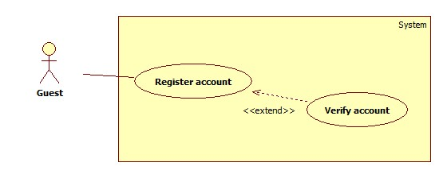

|  |  |  |  |
| --- | --- | --- | --- |
| **USE CASE – GU001** | | | |
| **Use Case No.** | GU002 | **Use Case Version** | 1.0 |
| **Use Case Name** | Register | | |
| **Author** | Tran Le Tuan | | |
| **Date** | 15/01/2014 | **Priority** | Normal |
| **Actor:** Guest.  **Summary:**  Guest use this case to register account into system.  **Goal:**  Allow guest register account into system.  **Triggers:**   * Guest want to register account. * To register: Guest go to the register page, guest enter username, password, email, address then click on “Đăng ký” button to register.   **Preconditions:** N/A.  **Post Conditions:**   * **Success:** System will show success message on current page * **Fail:** System will show error message on current page   **Main Success Scenario:**   |  |  |  | | --- | --- | --- | | Step | Actor Action | System Response | | 1 | Guest click on “Đăng ký” button. | System redirect to register page, contain a register form:   * “Tên đăng nhập”: textbox (min length: 5, max length: 30, required). * “Mật khẩu”: textbox (password box, min length: 5, max length: 30, required). * “Nhập lại mật khẩu”: textbox (password box, min length: 5, max length: 30, required). * “Email”: textbox ( [abc@xyz.com](mailto:abc@xyz.com)) required. * “Đăng ký” button. | | 2 | Guest enter register information.  Press “Đăng ký” button. | System send verify email and show the success message: “Bạn đã đăng ký thành công, vui lòng xác nhận email để kích hoạt tài khoản”.  [Exception 1, 2, 3, 4, 5] | | 3 | Guest verify account | System show message “Chúc mừng bạn kích hoạt thành công” and redirect to homepage  [Exception 6] |   **Alternative Scenario:** N/A  **Exceptions:**   |  |  |  | | --- | --- | --- | | No | Actor Action | System Response | | 1 | Missing information. | Show error message: “Vui lòng nhập đầy đủ thông tin”. | | 2 | Username/Password not in range [5,30] | Show error message: “Tên đăng nhập và mật khẩu phải từ 5-30 ký tự”. | | 3 | Input invalid retype password. | Show error message: “Thông tin nhập vào không đúng”. | | 4 | Input invalid email. | Show error message: “Email không hợp lệ” | | 5 | Existed username/email | Show error message: “Tên đăng nhập hoặc email đã được sử dụng” | | 6 | Verify link is expired | Show error message: “Đã hết hạn kích hoạt. Liên lạc với admin để có thêm thông tin” |   **Relationships:** N/A  **Business Rules:**   * Each user can register an account. | | | |

Search traffic

Search auto

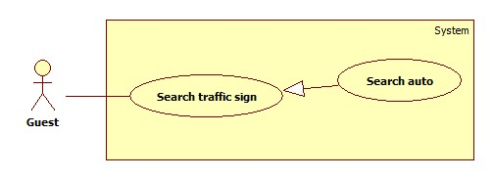

|  |  |  |  |
| --- | --- | --- | --- |
| **USE CASE – GU003** | | | |
| **Use Case No.** | GU003 | **Use Case Version** | 1.0 |
| **Use Case Name** | Search auto | | |
| **Author** | Mai Van Tan | | |
| **Date** | 15/01/2014 | **Priority** | High |
| **Actor:** Guest  **Summary:**   * Guest use this use case to make auto search   **Goal:**   * Allow guest auto search a traffic by take a photo or upload a photo.   **Triggers:**   * Guest want to search traffic sign * Guest clicks on the “Tìm kiếm tự động” button, take a photo and submit. * Waiting for result and click on traffic sign to view traffic sign information.   **Preconditions:**  **Post Conditions:**   * **Success**: Show the information of the traffic sign. * **Fail:** Show error message   **Main Success Scenario:**   |  |  |  | | --- | --- | --- | | Step | Actor Action | System Response | | 1 | Guest click on “Tìm kiếm tự động’ item. | System will show a screen contain:   * Button to take camera picture (only in mobile version) * Button to select image file * Submit button | | 2 | Guest click on take camera picture  [Alternative 1] | System show the camera screen that allow user take a picture | | 3 | Guest submit the picture | System upload picture to server, redirect to result page and so message: “Máy chủ đang xử lý, vui lòng đợi hoặc bấm nút quay lại để tiếp tục tìm kiếm”  [Exception 1] | | 4 | Guest waiting for result  [Alternative 2] | System show the result when receive respond from server:   * The submitted picture * The list result of search   [Exception 2] | | 6 | Guest click to the result item | System show the traffic sign information |   **Alternative Scenario:**  **1.**   |  |  |  | | --- | --- | --- | | Step | Actor Action | System Response | | 1 | Guest click on select image file | System show select image file windows | | 2 | Guest click upload image button | System upload picture to server, redirect to result page and so message: “Máy chủ đang xử lý, vui lòng đợi hoặc bấm nút quay lại để tiếp tục tìm kiếm” | | 3 | Reference to main scenario |  |   **2.**   |  |  |  | | --- | --- | --- | | Step | Actor Action | System Response | | 1 | Guest press back button to search | System redirect to auto search page | | 2 | When receive result from server | System notify to user to view the result | | 3 | Guest click to view result | System show the screen contain:   * The submitted picture * The list result of search   [Exception 2] | | 4 | Guest click to the result item | System show the traffic sign information |   **Exceptions:**   |  |  |  | | --- | --- | --- | | No | Actor Action | System Response | | 1 | User in mobile and not have internet connection | Show message “Kết nối internet không khả dụng. Ứng dụng sẽ tự động xử lý khi có internet”. And redirect to search auto screen. | | 2 | No result found | Show message “Không tìm thấy biển báo” suggest user to user manually search or make an auto search again |   **Relationships: N/A**  **Business Rules: N/A** | | | |

Search manually

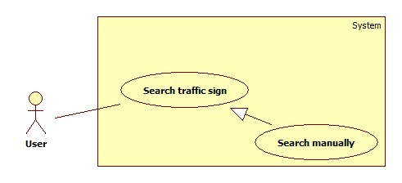

|  |  |  |  |
| --- | --- | --- | --- |
| **USE CASE – GU004** | | | |
| **Use Case No.** | GU004 | **Use Case Version** | 1.0 |
| **Use Case Name** | Search traffic sign in manually | | |
| **Author** | Mai Van Tan | | |
| **Date** | 15/01/2014 | **Priority** | Normal |
| **Actor:** Guest  **Summary:**   * Guest uses this case to search traffic sign in manually.   **Goal:**   * Allow guest search traffic sign in manually.   **Triggers:**   * Guest want to search traffic sign * Guest click on “Tra cứu biển báo”, select type of traffic sign then select traffic sign.   **Preconditions:** N/A  **Post Conditions:**   * **Success**: The information of the traffic sign. * **Fail:** No traffic sign is found.   **Main Success Scenario:**   |  |  |  | | --- | --- | --- | | Step | Actor Action | System Response | | 1 | Guest clicks on “Tra cứu biển báo” item. | Show the search history screen:   * A textbox to input text. * A search button. * A list contain of main type traffic sign. | | 2 | Guest clicks on a type of traffic sign | Show the list of traffic sign in selected type. | | 3 | User clicks on a traffic sign item | Show the information of the traffic sign |   **Alternative Scenario:**   |  |  |  | | --- | --- | --- | | Step | Actor Action | System Response | | 1 | Guest clicks on search history item. | Show the search history screen:   * A textbox to input text. * A search button. * A list contain of main type traffic sign. | | 2 | Guest input key work and press search button | Show the list of traffic sign match result  [Exception 1] | | 3 | Guest clicks on a traffic sign item | Show the information of the traffic sign |   **Exceptions:**   |  |  |  | | --- | --- | --- | | No | Actor Action | System Response | | 1 | Not traffic sign match with the key work | Show message “Không tìm thấy” |   **Relationships: N/A**  **Business Rules: N/A** | | | |